REGISTER FOR IBM CLOUD

TEAM MEMBERS

|  |  |  |
| --- | --- | --- |
| **H.KEERTHANA** | **-** | **422619104301** |
| **HARINI.M** | **-** | **422619104028** |
| **NANDITHA.P** | **-** | **422619104047** |
| **MADHUMITHA.S** | **-** | **422619104049** |

H.KEERTHANA (190801087) created IBM cloud account

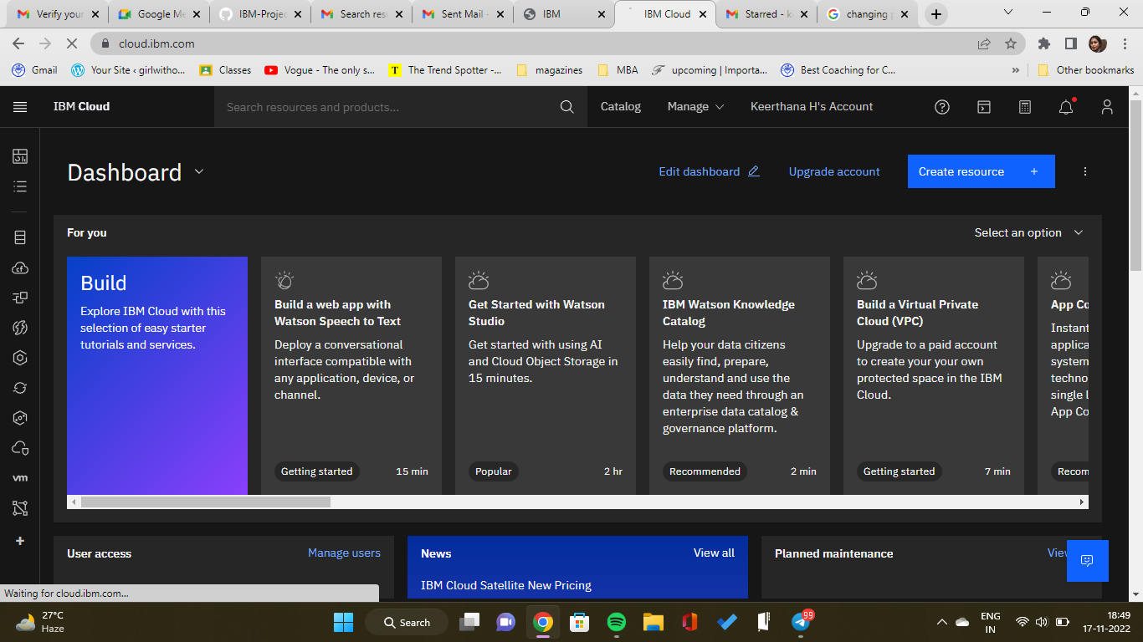

**HARINI.M (190801060) created IBM cloud account**

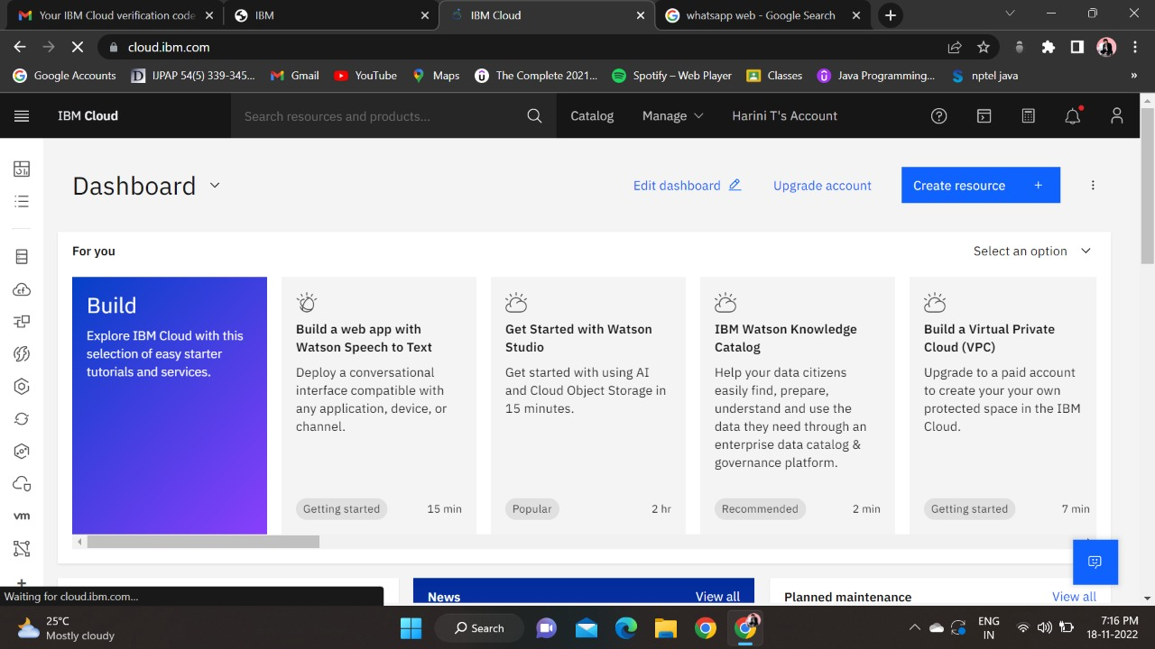

**NANDITHA.P (190801102) created IBM cloud account**

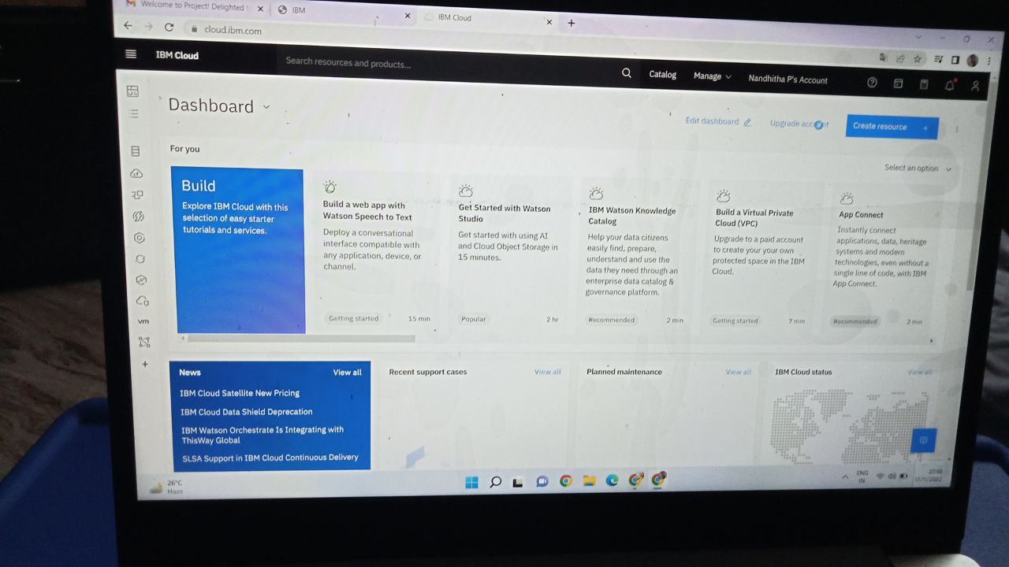

MADHUMITHA.S (190801098) created IBM cloud account

